**BEGINNING OF TERM ONE EXAMINATIONS 2024**

**Intelligence 5-6 years**

Name ___________________________Stream ______________

1. **Circle these words in the puzzle.**

cow man two

rat win six

m a n z x s y t w o

p q r s t i x l n q

w i n u v x t c o w

a c d f g i b k m p

b r a t e h o j r s

[](https://www.google.com/url?q=http://gallery.coloringcrew.com/jobs/cooks/spoon-colored-by-anel-19954.html%26sa=U%26ei=cOc8U9uSGoadtQb_s4Ew%26ved=0CD4Q9QEwBw%26usg=AFQjCNFNmdRD-edM4UV-JyMzmUcAOQZy_g)[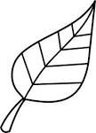](http://www.google.com/imgres?imgurl=http://sweetclipart.com/multisite/sweetclipart/files/nature_seasons_leaf_spring_or_autumn_lineart.png%26imgrefurl=http://sweetclipart.com/colorable-line-art-leaf-386%26usg=__HKwOsswgVWLYgiRUUlznAEd6lgA=%26h=5176%26w=3734%26sz=268%26hl=en%26start=30%26zoom=1%26tbnid=srMpyKfZX45iLM:%26tbnh=150%26tbnw=108%26ei=v3SEUsfIH8rYtAaNsoHICg%26itbs=1%26sa=X%26ved=0CEAQrQMwCTgU)2. **Match the belongings.**

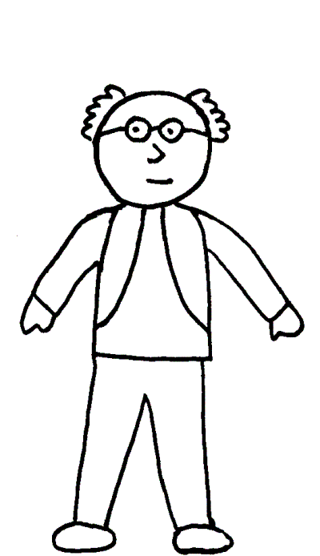[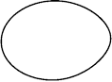](http://www.google.com/url?url=http://clipgid.com/egg-clipart-black-and-white.html%26rct=j%26frm=1%26q=%26esrc=s%26sa=U%26ved=0CC4QwW4wC2oVChMI2PmF5PiyyAIVQzYaCh2WGwNz%26usg=AFQjCNFTWw3o4WCB7OZDx-zUF6Oo4UrVXw)

[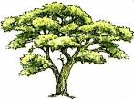](http://www.google.com/imgres?imgurl=http://www.arthursclipart.org/trees/trees/camelthorn.gif%26imgrefurl=http://www.picstopin.com/1460/arthurs-tree-clipart-page-1-hawaii-dermatology/http:||www*arthursclipart*org|trees|trees|beech%203*gif/%26usg=__h9Opd4Z6Op58zfi_N1kXw187O8c=%26h=679%26w=919%26sz=139%26hl=en%26start=61%26zoom=1%26tbnid=OGRYAu30UkXe1M:%26tbnh=109%26tbnw=147%26ei=BRC4UeCXINKrhQe3voDIBQ%26prev=/search?q=trees%26start=60%26sa=N%26hl=en%26sout=1%26biw=985%26bih=443%26site=imghp%26tbs=itp:clipart%26tbm=isch%26itbs=1%26sa=X%26ved=0CC4QrQMwADg8)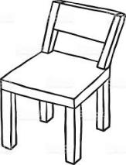

[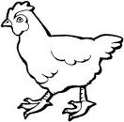](http://www.google.com/imgres?imgurl=http://www.centrodelenguas.iteso.mx/lablenguas/pix/hen.jpg%26imgrefurl=http://www.centrodelenguas.iteso.mx/lablenguas/html/anim_3.htm%26usg=__F7QPrXFPjGtRmVGA0rfDz4iqc0o=%26h=533%26w=540%26sz=33%26hl=en%26start=17%26zoom=1%26tbnid=rRFodziOke5tBM:%26tbnh=130%26tbnw=132%26ei=f0cwUa3CDdGT0QWanIGIDw%26prev=/search?q=hen%26hl=en%26sa=X%26gbv=2%26tbs=itp:lineart%26tbm=isch%26itbs=1%26sa=X%26ved=0CEwQrQMwEA)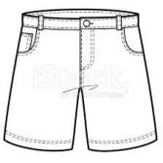

[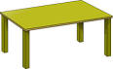](http://www.google.com/url?url=http://www.clipartsheep.com/table-clipart/dT1hSFIwY0RvdkwyVjBZeTUxYzJZdVpXUjFMMk5zYVhCaGNuUXZORGN3TUM4ME56YzVMM1JoWW14bFh6RmZiR2N1WjJsbXx3PTEwMjR8aD02MDR8dD1naWZ8/%26rct=j%26frm=1%26q=%26esrc=s%26sa=U%26ved=0CCwQwW4wCmoVChMI_IiRua2RxwIVrW7bCh2y0Afx%26usg=AFQjCNGtjFM5uACSctAQ3A5ZyGlNlPLD_Q)[](http://www.google.com/imgres?imgurl=http://www.clker.com/cliparts/t/j/P/p/E/O/b-w-coffee-cup-md.png%26imgrefurl=http://www.clker.com/clipart-b-w-coffee-cup.html%26usg=__8BoC3ER5MowE62E8Y8Z2qYgtUlI=%26h=270%26w=297%26sz=9%26hl=en%26start=14%26zoom=1%26tbnid=Ao6a3NJFyTaCIM:%26tbnh=105%26tbnw=116%26ei=K4fvUfe_BofLhAer6oGICQ%26prev=/search?q=cups%26sa=X%26hl=en%26sout=1%26biw=1341%26bih=555%26site=imghp%26tbs=itp:clipart%26tbm=isch%26itbs=1%26sa=X%26ved=0CEgQrQMwDQ)

3. **Circle the odd man out.**

[](http://www.google.com/imgres?imgurl=http://www.centrodelenguas.iteso.mx/lablenguas/pix/hen.jpg%26imgrefurl=http://www.centrodelenguas.iteso.mx/lablenguas/html/anim_3.htm%26usg=__F7QPrXFPjGtRmVGA0rfDz4iqc0o=%26h=533%26w=540%26sz=33%26hl=en%26start=17%26zoom=1%26tbnid=rRFodziOke5tBM:%26tbnh=130%26tbnw=132%26ei=f0cwUa3CDdGT0QWanIGIDw%26prev=/search?q=hen%26hl=en%26sa=X%26gbv=2%26tbs=itp:lineart%26tbm=isch%26itbs=1%26sa=X%26ved=0CEwQrQMwEA)[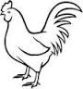](http://www.google.com/imgres?imgurl=http://ec.l.thumbs.canstockphoto.com/canstock11107356.jpg%26imgrefurl=http://www.canstockphoto.com/vector-clipart/cock.html%26usg=__s8Mz22BMkyi4QZeFEvx5i97N_bM=%26h=150%26w=141%26sz=6%26hl=en%26start=15%26zoom=1%26tbnid=CRm87PXBk-rS3M:%26tbnh=96%26tbnw=90%26ei=S0cwUba0BqmU0QXg14GACw%26prev=/search?q=cock%26hl=en%26sa=X%26gbv=2%26tbs=itp:clipart%26tbm=isch%26itbs=1%26sa=X%26ved=0CEgQrQMwDg)

[](http://www.google.com/imgres?imgurl=http://ec.l.thumbs.canstockphoto.com/canstock11107356.jpg%26imgrefurl=http://www.canstockphoto.com/vector-clipart/cock.html%26usg=__s8Mz22BMkyi4QZeFEvx5i97N_bM=%26h=150%26w=141%26sz=6%26hl=en%26start=15%26zoom=1%26tbnid=CRm87PXBk-rS3M:%26tbnh=96%26tbnw=90%26ei=S0cwUba0BqmU0QXg14GACw%26prev=/search?q=cock%26hl=en%26sa=X%26gbv=2%26tbs=itp:clipart%26tbm=isch%26itbs=1%26sa=X%26ved=0CEgQrQMwDg)

[http://t0.gstatic.com/images?q=tbn:ANd9GcQiM0KTr96JDvnJ1v30AyNxxcTBtFKn30DtrDnqV8lFa_R4bge1Z2JJdAhttp://t0.gstatic.com/images?q=tbn:ANd9GcQiM0KTr96JDvnJ1v30AyNxxcTBtFKn30DtrDnqV8lFa_R4bge1Z2JJdA](http://www.google.co.ug/imgres?imgurl=http://www.clker.com/cliparts/3/7/d/5/1197103862376117882Gioppino_Soccer_Ball.svg.med.png%26imgrefurl=http://www.clker.com/clipart-14508.html%26usg=__7U6rlynz93qgG9aWfh9nXomep6k=%26h=294%26w=300%26sz=34%26hl=en%26start=2%26zoom=1%26tbnid=JkD4fuFLI-MdlM:%26tbnh=114%26tbnw=116%26ei=JNfRT4WZMamO0AXHpu2MBA%26prev=/search?q=balls%26hl=en%26sa=X%26gbv=2%26tbs=itp:clipart%26tbm=isch%26itbs=1)

[http://t1.gstatic.com/images?q=tbn:ANd9GcQYZQBkUy5PSnMI517sslXkexSWpvZvqJj_XVoIaMVEKe2rBdk174VPlx0](http://www.google.co.ug/imgres?imgurl=http://www.free-clipart-pictures.net/free_clipart/softball_clipart/softball_clipart_ball_2.gif%26imgrefurl=http://www.free-clipart-pictures.net/softball_clipart.html%26usg=__QHD25yNKZCQBFhuWg_mOzoTiL0g=%26h=200%26w=200%26sz=9%26hl=en%26start=15%26zoom=1%26tbnid=2Tw9ILBw0H6FEM:%26tbnh=104%26tbnw=104%26ei=JNfRT4WZMamO0AXHpu2MBA%26prev=/search?q=balls%26hl=en%26sa=X%26gbv=2%26tbs=itp:clipart%26tbm=isch%26itbs=1)

[http://t1.gstatic.com/images?q=tbn:ANd9GcTY-tRZK3gXtytxj1InyzTXZU-SBAPtzcC82Y5aGoWP1K_LDNr7tiW0o_M](http://www.google.co.ug/imgres?imgurl=http://0.tqn.com/d/webclipart/1/0/y/M/4/tree3.gif%26imgrefurl=http://webclipart.about.com/library/agarden/bltrees1.htm%26usg=__ncvSCKVUYC7THclAHlmvPZnqXx0=%26h=354%26w=246%26sz=31%26hl=en%26start=12%26zoom=1%26tbnid=sJYZh-Funx3WYM:%26tbnh=121%26tbnw=84%26ei=ANXRT76-L7KW0QW-29S8BA%26prev=/search?q=trees%26hl=en%26sa=X%26gbv=2%26tbs=itp:clipart%26tbm=isch%26itbs=1)[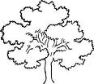](http://www.google.co.ug/imgres?imgurl=http://www.clker.com/cliparts/6/b/1/4/11970948901823867731johnny_automatic_oak_tree.svg.med.png%26imgrefurl=http://www.clker.com/clipart-13736.html%26usg=__jNUGJx61Qx-dJPX00vwJn1_mJZ0=%26h=267%26w=300%26sz=22%26hl=en%26start=14%26zoom=1%26tbnid=XH25gvLpZJByhM:%26tbnh=103%26tbnw=116%26ei=ANXRT76-L7KW0QW-29S8BA%26prev=/search?q=trees%26hl=en%26sa=X%26gbv=2%26tbs=itp:clipart%26tbm=isch%26itbs=1)[http://t1.gstatic.com/images?q=tbn:ANd9GcTY-tRZK3gXtytxj1InyzTXZU-SBAPtzcC82Y5aGoWP1K_LDNr7tiW0o_M](http://www.google.co.ug/imgres?imgurl=http://0.tqn.com/d/webclipart/1/0/y/M/4/tree3.gif%26imgrefurl=http://webclipart.about.com/library/agarden/bltrees1.htm%26usg=__ncvSCKVUYC7THclAHlmvPZnqXx0=%26h=354%26w=246%26sz=31%26hl=en%26start=12%26zoom=1%26tbnid=sJYZh-Funx3WYM:%26tbnh=121%26tbnw=84%26ei=ANXRT76-L7KW0QW-29S8BA%26prev=/search?q=trees%26hl=en%26sa=X%26gbv=2%26tbs=itp:clipart%26tbm=isch%26itbs=1)

4. **Match the same words and draw pictures.**

hut broom ____________

fish door ____________

house hut ____________

door fish ____________

broom house ____________

5. **Circle a word for a number.**

3 three one

2 zero two

6 six ten

9 four nine

5 five vefi

6. **Put me right.**

upc ________________ atm _____________

int ________________